Table of Contents

Executive Summary 2
Project Objectives 3
System Requirements Specification 3
Functional Requirements 3
Non-Functional Requirements 4
Project Design Methodology 4
Chosen Methodology: Agile (Scrum) 4
System Architecture 5
Frontend (Presentation Layer) 5
Backend (Application Layer) 5
Database Layer 5
UML Diagrams 5
Use Case Diagram 5
Entity Relationship Diagram 6
Sequence Diagram: Referral Submission 7
Project Planning 11
Work Breakdown Structure (WBS) 11
Group Member Roles and Responsibilities 11
Prototype Design 11
Low-Fidelity Prototype 11
High-Fidelity Prototype 12
Sample Use Case Scenario 12
Ethical Issues and Compliance 13
Data Privacy 13
Security Risks and Mitigation 13
Transparency in Referral Handling 13
Fairness and Non-Discrimination 13
Regulatory Compliance 14
Conclusion 14

Executive Summary

Referral Network Portal is a specifically designed online system that aims to provide a solution for the lack of digital management in partner referrals throughout the Australian mortgage and real estate sectors. Many brokerages of medium and small sizes use Excel spreadsheets, emails, and phone conversations as a means to keep tabs on partners' referrals, which leads to a host of issues such as lost referrals, long response times, disputes on commissions, and privacy breaches.
This document describes a capstone design project in which the design process and prototype documentation are produced to present the complete design of Referral Network Portal system. Users (e.g., partners) of the system refer new clients, and these client details are kept in the system and managed by brokers. An administrative function controls the use of users, commission calculations, and legal compliance of the system in accordance to Privacy Act 1988 and Spam Act 2003. The entire document contains the requirements, design, UML diagrams, project planning, and prototype for Referral Network Portal. The screenshots for this report are from a prototype of the actual interface.

Project Objectives

The project's five key goals are:
- Centralised referral management: Move away from a spreadsheet and manage all referrals from all partners in one system.

- Transparency on referral status: The current process for brokers and partners to understand where a referral has reached in the journey (Received > Reviewing > Referred > Converted > Settled) can be time consuming to manually track.

- Calculate and display partner commission automatically: Partners are rewarded for each referral that settles, with a higher commission for Gold partners (25%) compared to Silver partners (20%) per settled referral.

- Compliance embedded in the platform: Manage consent to comply with privacy and Australian law, provide a full audit trail and data security.

- Dashboards for analytics, insights and recommendations: Role-specific dashboards that show partner leaderboard, referral pipeline funnel, conversion metrics, and predicted commission values.

System Requirements Specification

Functional Requirements

Functional requirements define the specific behaviours the system must perform. The following table outlines the core functional requirements identified for the Referral Network Portal:
ID | Requirement | Priority
1 | User registration with email verification and role selection (Partner, Broker, Admin, Auditor) | High
2 | Role-based access control ensuring each user type can only access appropriate system functions | High
3 | Referral submission form including client name, suburb, loan type, estimated amount, and mandatory consent checkbox | High
4 | Real-time referral status tracking (Pending, Qualified, Lodged, Approved, Settled, Declined) | High
5 | Document upload capability for attaching client-related files to referral records | Medium
6 | Notification system delivering email and in-app alerts on referral status changes | Medium
7 | Partner dashboard displaying total referrals, commissions earned, pending payouts, and conversion rate | High
8 | Commission calculation module based on partner tier and broker upfront commission upon settlement | High
9 | Admin panel for user management, commission overrides, partner tier adjustment, and audit log review | High
10 | Audit trail recording all system changes with actor identity, timestamp, and action type | High

Non-Functional Requirements

ID | Requirement | Metric / Validation
1 | Security: Role-based access control (RBAC), TLS 1.2+ encryption, AES-256 data at rest | Compliance audit
2 | Usability: Non-technical partners can complete a referral submission in under 3 minutes | User testing
3 | Performance: System responds to all user actions within 2 seconds under normal load | Load testing
4 | Scalability: Architecture supports 500+ concurrent partners and 50,000+ referral records | Stress testing
5 | Reliability: 99.5% uptime target with automated failover and database backups | Uptime monitoring
6 | Compliance: Full adherence to Privacy Act 1988 (APP guidelines) and Spam Act 2003 | Legal review

Project Design Methodology

Chosen Methodology: Agile (Scrum)

The Scrum approach of agile software development was the approach of choice for the Referral Network Portal for a few reasons. The needs of the different types of users of a referral management system will differ, but these needs might change as the users' circumstances change and this could require the needs of the users to be changed in the development process; Agile allows the team to go back and change requirements according to what they find at the end of each sprint, while delivering working software.

Also with the short timeframe of the 12 weeks to develop the whole application, the team needed a method that would allow them to build out pieces of the application and deliver working software for different pieces at different times rather than wait to deliver the final working product at the end of all 12 weeks.

The different members of the team all have the opportunity to provide feedback to the development of the application as they are working in the different functional teams: design, develop and test, and they are all involved at some point during development of the portal. This approach was very important because it allows every member to have a voice in the development of the project. As mentioned previously, the sprint approach works well because the different members of the team all are working in teams that can communicate with the overall product owner during the development process, and the cross functional team approach of scrum fits very well in this situation because you would need to combine the knowledge from every area to create this product.

Each sprint will be two weeks in duration and will correspond to a phase in the implementation plan (requirements, design, core development, reporting, testing, and deployment). At the end of the sprint, there will be a retrospective meeting in which to analyze how the previous development process went. This gives the team the ability to adjust the process as the product is being built. It also ensures that requirements are constantly added to the product backlog if new requirements are discovered during the previous sprint's planning and execution.

System Architecture

The system employs a three-tier client-server architecture, structured to separate the frontend, backend, and data layer.

Frontend (Presentation Layer)

The frontend constitutes a responsive web application, serving users through modern web browsers on both desktop and mobile devices. Leveraging React.js, it adheres to a component-based framework that accommodates the different user dashboard types required by each user tier. These user dashboard types encompass the partner dashboard, the new referral form, and the broker pipeline dashboard. The frontend design is simple and straightforward in accordance with the wireframe sketches in the prototype screenshots, as its intended audience is partner users with little to no technical knowhow.

Backend (Application Layer)

The backend leverages Node.js in conjunction with Express.js to serve a REST API. This layer manages various core functions including the user authorization (JWT based), access control by role, referral life cycle management, commission calculation, and notification delivery. The service-based architecture is designed to be stateless and is capable of expanding horizontally alongside user growth. To be specific, the commission service calculates partner payouts using a defined formula: partner share = broker upfront commission x (partner tier rate / 100), that is executed in real time with referral status updates of 'Settled'.

Database Layer

PostgreSQL serves as the RDBMS, containing all the persistent data: user accounts, partner profiles, referral information, document metadata, commission data, and logs of auditing activity. The core tables for this data are User, Partner, Referral, Commission, Document and Notification.

A variety of foreign keys enforce data integrity. For example, a single Referral can have a single Partner or user account (in the case of a Broker User) associated with it; similarly, a single Commission table row can have one Referral and one Partner associated with it. All fields containing personal information are encrypted on disk, utilizing the AES-256 standard.

UML Diagrams

Use Case Diagram

The use case diagram outlines four actors: Partner, Broker, Admin, and Auditor.

Partner: Register Account, Login, Submit Referral, View Referral Status, View Commission Dashboard, and Download Payout Statement.
Broker: Login, Review Referrals, Update Referral Stage, Add Notes to Referral, Generate Partner Report.
Admin: Approve Partner Registration, Manage Commission Rates, View Audit Logs, Export Data, Override Commissions.
Auditor: View Audit Logs, Review Referral History, Verify Commission Calculations.

Login is a use case that all actors interact with, which expands into Secure Authentication.
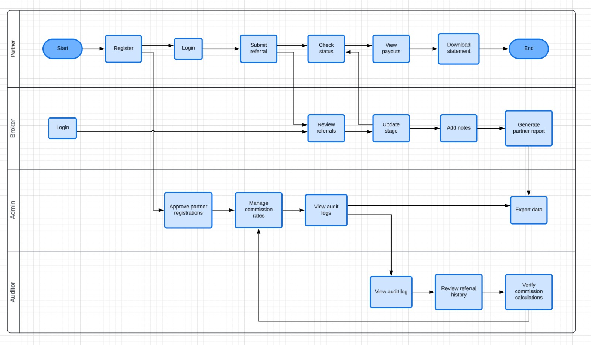

Entity Relationship Diagram

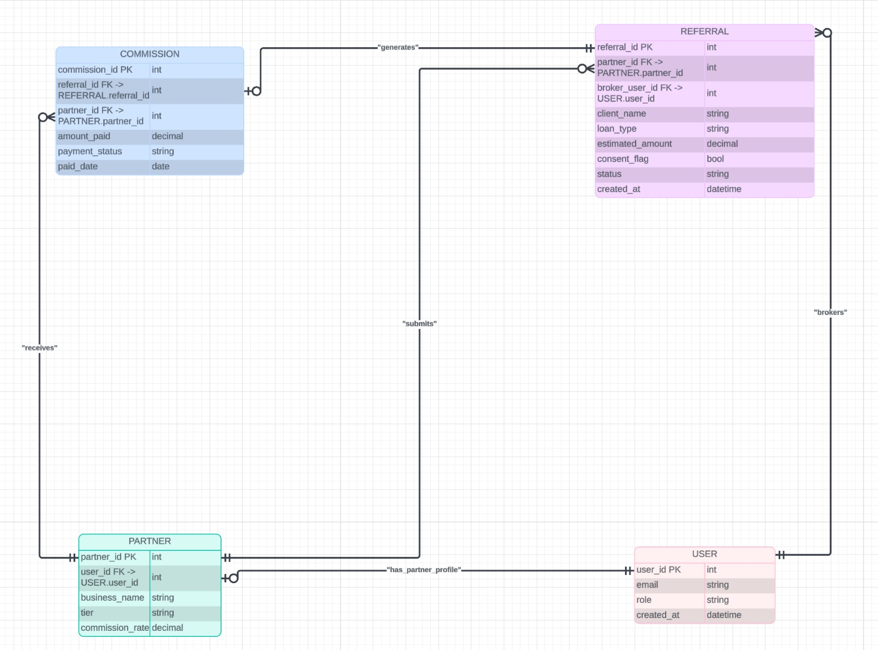

Sequence Diagram: Referral Submission

The referral submission process involves the following steps:

- The Partner goes to the New Referral form and fills in the information along with client data and consent

- The Frontend submits a POST /referrals request to the Backend API

- The Backend API confirms that the JWT is valid, the Partner role and status are approved and inserts a new entry to the Database with a status of Received

- The Backend API instructs the Notification Service to send an Acknowledgement email to the Partner

- The Backend API responds with 201 Created back to the Frontend API

- The Frontend displays a Success notification for the Partner.

The referral is also now viewable in the Broker Pipeline in the 'New Leads' section of the Pipeline..
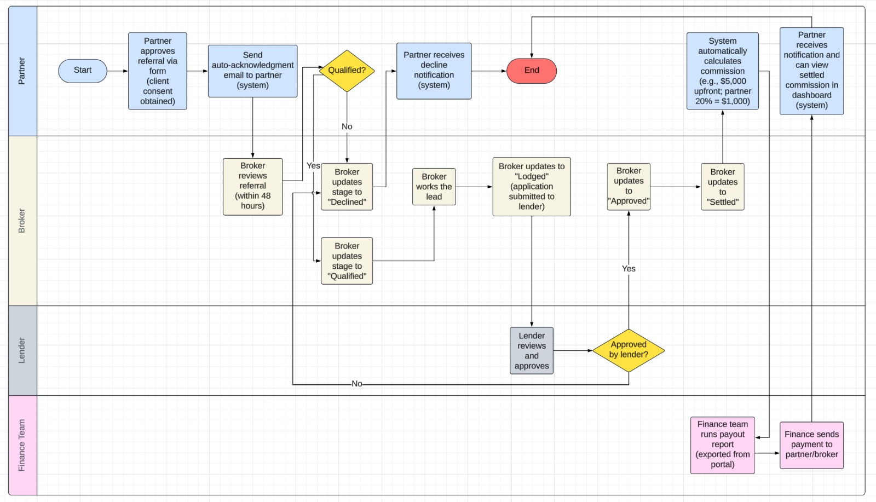

 | Referral Network Portal — Project Gantt Chart
 |  |  | W1 | W2 | W3 | W4 | W5 | W6 | W7 | W8 | W9 | W10 | W11 | W12
 | 1. Requirements Gathering | Angel · Pedro
 | Stakeholder interviews & user stories | Angel
 | SRS documentation | Pedro
 | ERD drafting | Ashish
 | Wireframe sketching | Ashish
 | SRS Sign-Off |  |  | ◆
 | 2. System Design | Ashish · Pemba
 | Architecture & three-tier design | Pemba
 | UML diagrams (use case, class, sequence) | Ashish
 | Database schema finalisation | Pemba
 | High-fidelity Figma prototype | Ashish
 | Design Freeze |  |  |  |  |  | ◆
 | 3. Core Development | Pemba · Apsara
 | User auth module (JWT, RBAC) | Pemba
 | Referral CRUD & pipeline API | Pemba
 | Commission calculation engine | Pemba
 | Email notification service | Apsara
 | Admin panel | Apsara
 | Feature Complete |  |  |  |  |  |  |  |  | ◆
 | 4. Dashboards & Reporting | Apsara · Ashish
 | Partner dashboard & analytics | Apsara
 | Broker pipeline view (kanban) | Apsara
 | Commission & payout reports | Ashish
 | Dashboard Review |  |  |  |  |  |  |  |  |  |  | ◆
 | 5. Testing & Compliance | Apsara · Pedro
 | Unit & integration testing | Apsara
 | User acceptance testing (UAT) | Apsara
 | Security penetration testing | Pemba
 | Privacy Act 1988 compliance audit | Pedro
 | QA Sign-Off |  |  |  |  |  |  |  |  |  |  |  | ◆
 | 6. Deployment & Training | All members
 | Production deployment & runbook | Pemba
 | User guides & documentation | Pedro
 | Final report & submission | Angel
 | Final Submission |  |  |  |  |  |  |  |  |  |  |  |  | ◆

Project Planning

Work Breakdown Structure (WBS)

- Requirements Gathering: Conducted stakeholder interviews, drafted user stories and SRS, sketched out ERDs, and created wireframes.

- System Design: Defined the system architecture, developed UML use cases, classes, and sequences, finalised the database schema, and created high-fidelity UI/UX designs in Figma.

- Prototype Development: Delivered a fully functional user login module, referral management (CRUD), role-based access controls, commission engine, email notification services, admin portal, partner dashboard, and broker pipeline interface.

- Testing: Executed unit testing on API interfaces, ran integration testing on the commission engine, facilitated UAT sessions with sample partner and broker participants, performed security penetration testing, and conducted a privacy compliance audit.

- Documentation: Submitted the final SRS report, comprehensive prototype documentation, compliance declaration, end-user guides, deployment procedures, and the final project submission document..

Prototype Design

Low-Fidelity Prototype

At the very beginning of the project, before any development had occurred, a low-fidelity prototype was used in order to test new ideas and concepts quickly and to obtain feedback from the project stakeholders. The prototype contained hand-drawn wireframe sketches that depicted the following five screens:
- Login/Register
- Partner Dashboard
- New Referral Submission Form
- Referral Tracking (Broker Pipeline)
- Admin Panel
A simple login and registration form was shown in a login and register page sketch. Users would need to input their email and password to log in, and when registering for the first time, they could also select their role.
A 2x2 grid displaying the metrics of the partner would be shown on the partner dashboard: Total Referrals, Total Commissions Earned, Total Pending Payouts, and Total Conversion Rate. There was also a bar chart to display monthly submissions, and there was a sidebar showing recent payouts.
A labelled field was included on the referral submission form sketch so the partners could input their client's name, email address, phone number, suburb, loan type, and estimated loan amount. A checkbox and a button to submit the referral were also included.
The referral tracking (broker pipeline) sketch displayed each stage of the referral process. There was a column for each stage of the process. The admin panel sketch contained a table of partner accounts along with the buttons to approve a partner account and edit their tier.
A low-fidelity prototype was created for a couple of reasons. One of the most valuable parts of creating low-fidelity prototypes is that you can find usability issues and concerns about the alignment of the user interface (UI) and user experience (UX) before you invest resources in high-fidelity prototypes and development.
The feedback from the low-fidelity wireframes were that a 'Notes (Optional)' field should be added to the referral submission form. The 'Notes (Optional)' field is located below the 'Client's Loan Amount' field. It was also decided that adding +2 more (expandable cards) should be added to the broker pipeline.

High-Fidelity Prototype

After the low-fidelity validation stage, the high-fidelity prototype was developed in Figma, integrating accurate typography, colors, interaction behaviors, and navigation. For all screens, the final design features a dark navy (#1F3864) header navigation bar with white text to create an appearance consistent with professional and reliable financial services.
As per the implemented screenshot, the Partner Dashboard displays four metric cards with responsive layout. Each metric card includes a unique icon, a label, value, and a trend indicator arrow, colored either green (indicating positive growth) or red (indicating negative growth). The Performance metric renders a bar chart populated by monthly referrals data to illustrate a history of referral submissions by the Partner. The Recent Payouts metric shows a table view of the most recent payouts by client. Finally, all screens are navigable through the navigation bar in the header, containing the links: 'Partner Dashboard', 'New Referral' and 'Broker Pipeline', in addition to the user avatar and a notification button in the header.
As per the implemented screenshot, the New Referral form uses the card based modal design, with light gray background. The form labels all fields with an appropriate label and placeholder text, with the 'Suburb' having the value 'e.g., Bondi Beach, NSW'. The loan type drop-down is defaulted to 'Owner-Occupied', and the Cancel and Submit Referral buttons are both styled with neutral and primary button styles, respectively, where the primary style is consistent with the dark navy (#1F3864) color used in the header navigation bar for all screens.
As per the implemented screenshot, the Broker Pipeline view shows the referral cards arranged into four columns with the following data: 'New Leads' (eight cards), 'In Progress' (12 cards), 'Approved' (five cards), 'Settled' (three cards). Each referral card includes a unique ID, a label for the Client Name, a value of the Loan Amount, the loan type, and a 'more' link in case the referral has multiple clients where the clients are displayed when the 'more' link is clicked.

Sample Use Case Scenario

The subsequent case exemplifies an end-to-end application of the system from three different user perspectives:
- Step 1 (Partner): Gold-level partner, Harry, signs in to the portal and accesses the New Referral screen. Harry inputs the data for his client, Mary (Investment loan, estimated amount of $850,000) and agrees to the client consent by using the required checkbox. Harry clicks ‘Submit Referral’ and the referral is saved in the system with status as 'Received', and an acknowledgement email is sent to Angel.

- Step 2 (Broker): The broker receiving the referral can view the referral in the Broker Pipeline under the 'New Leads' column. The broker contacts Mary within 24 hours and the referral is changed to the status of 'In Progress'. The broker also leaves a note on the referral. When the application is lodged and assessed by the lender, the broker changes the referral stage to 'Approved', and finally, to 'Settled'.

- Step 3 (Commission calculation): Upon settlement of the application, the system automatically calculates Harry commission: broker upfront commission * 25% (Gold status). The new commission is created with status 'Pending'.

- Step 4 (Admin): The admin downloads the commission payout report and makes the relevant bank payment and the status of the commission is then set to 'Paid'. Harry gets an email notification and views the payment under the Recent Payouts widget on her dashboard.

- Step 5 (Auditor): The Auditor is able to examine the referral audit trail for every single registration, referral submission, status change, commission creation and the commission payout, to ensure that the application is compliant with the data handling rules.

Ethical Issues and Compliance

Data Privacy

The portal stores various forms of sensitive information. These include: client names, contact information, client suburb, loan type and estimated financial details. This is governed by the Australian Privacy Act 1988, specifically the Australian Privacy Principles (APPs). In accordance with the APPs (APP 3), only essential personal information is collected and consent is required to send the data via the referral portal. The consent flag is stored with a timestamp and is stored with the referral itself for audit purposes.
Furthermore, APP 11 stipulates that all client data is secured via AES-256 encryption at rest, and encrypted data in transit with TLS 1.2+. Data retention period is set at seven years which is in keeping with standard industry practices, after which time data is anonymised but not destroyed outright so as to preserve some analytical value without risking personal information being retained indefinitely.

Security Risks and Mitigation

The portal poses several security risks and challenges for the user. The most significant are unauthorised access to personal data, compromised credentials and injection attacks. The design mitigates these in the following ways:
- The RBAC ensures that each user has only access to data and actions pertinent to their role.

- Additionally, each user is granted a JWT for access which has a finite lifespan which helps mitigate the effects of credential theft.

- Input validation ensures no malicious scripts or SQL queries can be entered into the system.

- Finally, access logs are kept to allow for forensic auditing in case of a security breach.

Security and penetration testing for vulnerabilities is included as part of the Phase 5 implementation and maintenance phase in the final phase of the project..

Transparency in Referral Handling

The primary expectation of partners submitting referrals via the portal is to receive feedback on the status and progression of their referral. This has been met by incorporating the following features:
- Referral status changes will trigger an email sent to the partner and the status of the referral can be viewed in real-time by partners via the Partner Dashboard.

- Partners will also be able to view each referral history which will include any notes from brokers.

- Additionally, any dispute on commissions can be lodged by partners within 30 days after the referral commission has been paid. These commissions are then reviewed by the broker and the admin.
These ensure partners know what is happening with the referrals and that any decisions are fair and justifiable.

Fairness and Non-Discrimination

The commission calculation method used within the referral portal is based on the tier of the partner which determines the commission rate multiplied by the loan settlement amount. The system is therefore impartial in that these two variables cannot influence the commission awarded, thereby ensuring that the process is neither subject to the whims of the broker nor any personal prejudices or biases the broker may have against the referring party.

The team however acknowledges that the tiers themselves could be inherently discriminatory should they not be awarded equally across all referring agents. To overcome these concerns the admin portal will log any changes to the partner tiers in the audit trail. Any overrides on commission by the admin will also be logged. This means that regardless of background all referrals processed via the portal are subject to the same processing rules.

Regulatory Compliance

The system is also compliant with the Spam Act 2003. This ensures that any emails sent to users from the system are not considered spam. In the portal context, this means that the referral portal only sends emails to users who have consented to receive them by opting into the email notifications during the registration process. The emails will also contain a link to opt out from these emails in the future. No marketing emails to clients will be sent unless these clients have separately opted to receive them.

The referral network privacy policy is published as part of the system registration page which ensures that all potential users are aware of how their personal data is handled. Partners will also be able to request an export of their personal data in line with APP 12. All of the above are subject to the testing phase of the project which will involve the designated role of Compliance Auditor within the implementation team.

Conclusion
The proposed referral management platform is designed to address a significant industry problem currently faced by mortgage brokers: the difficulty in effectively managing partner referral relationships. This problem is solved by implementing a digital platform that will allow a broker to manage their referral network and the flow of data between them, in addition to providing them with transparency and a mechanism to resolve any issues arising from the referral network.

The platform has a positive impact on the users involved; for brokers it will simplify their workflow in that they will no longer have to manually track and process partner referrals through spreadsheets or emails. They will be provided with an easily manageable referral pipeline with notifications at every stage of the process. The system can also provide the transparency needed to resolve commission disputes in a structured, non-contentious manner that allows brokers to provide an audit trail in the event of disputes.

For referring agents, the system provides the assurance that they will know what has happened to a referral at all times, and will be notified if their client has gone on to settle a loan. This will remove any ambiguities regarding the status of the referrals and will increase the number of clients referred by the broker by improving agent trust in the system. Finally, the system can also provide transparency for the referring agent by ensuring any commission disputes can be resolved in a transparent manner, with the commission paid via an audit trail and dispute resolution pathway. This removes any ambiguity for partners as to whether they should be owed a commission for their referral.

For the administrator, the portal provides an audit trail for all actions taken within the referral system. This allows for easy review of all actions taken, in particular in resolving dispute resolution cases. All the above features will also be subject to a testing phase which will verify the functionality of the system.

